

**Department of Computer Science - BUIC**

**DBMS Semester Project**

**Competition Management System**

**Group Members:**

* Muhammad Awab Sial ( 01-134222-091 )
* Syed Amber Ali Shah ( 01-134222-146 )
* Shehroz Zahid ( 01-134222-141 )

**Submitted To: Ms. Sara Durrani**

Contents

Title: Competition Management System 3

Project objectives 3

Interview 3

Questionnaire 4

Results 5

System Users 6

Functionalities 7

Registration Process 7

Competition Management 7

Participant Management 7

Judging and Evaluation 7

Search Functionality 7

Reporting 7

Block Diagram 8

System Specifications 8

User Views 9

User Views & Wire-frames 10

Approach 41

Centralized Approach 41

List Of Entities 41

Attributes 42

List Of Relations 43

Constraints 43

Domains Of Attributes With Domain Constraints 43

Referential Integrity Constraint 46

Entity Entegrity Constraints 46

Key Constraints 47

Relation Definition 47

ERD 49

Block & Arrow 50

Tables and Constraints 51

# Title: Competition Management System

The Competition Management System aims to develop a comprehensive database system to facilitate the efficient management of competitions. This system will provide functionalities for organizing, scheduling, and monitoring various types of competitions, along with managing organizers, participants, judges, administrators, invigilators, and media persons.

# Project objectives

* To maintain (enter, update, and delete) competitions.
* To maintain (enter, update, and delete) contestants/participants.
* To maintain (enter, update, and delete) judges.
* To maintain (enter, update, and delete) invigilators.
* To maintain (enter, update, and delete) competition organizers.
* To maintain (enter, update, and delete) competition details.
* To maintain (enter, update, and delete) contest rules.
* To perform searches on upcoming contests.
* To perform searches on previous contests.
* To perform searches on judges.
* To perform searches on invigilators.
* To perform searches on past results.
* To perform searches on past problems.

# Interview

**Interviewee:** Muhammad Awab Sial ( Competitive Programming Head @ YOTA | ICPC Regionalist 23’ )

1. **Could you provide an overview of the current competition management system.**

Currently, we are doing almost everything manually, from checking to maintaining records everything is manual. In our system we create teams for each competition and usually a team has team lead and some volunteers to do the work.

1. **What challenges are you facing with this manual system ?**

Challenges faced in manual system are:

* If one team member register participants and their data is lost there will be no backup of data.
* There is no collaboration between teams.
* Judging criteria is not the same.

1. **What features do you think are must be in a competition management system ?**

In my opinion, the following features must be present in a competition management system.

* Centralized database.
* Record keeping.
* Rule book.
* Upcoming or past events details.

1. **How are participants registration and communication handled currently.**

Currently we are running a very inefficient system where we make WhatsApp groups for each event that informs the students about important details and stuff.

## Questionnaire

In the questionnaire, we ask different questions from different competition organizers.

1. Are You Satisfied With the Current System?
2. How important is the security of the system ?
3. On average, how many competitions are managed within a semester ?
4. How would you rate the current process of participant registration and communication? (1 being poor, 5 being excellent)

## Results

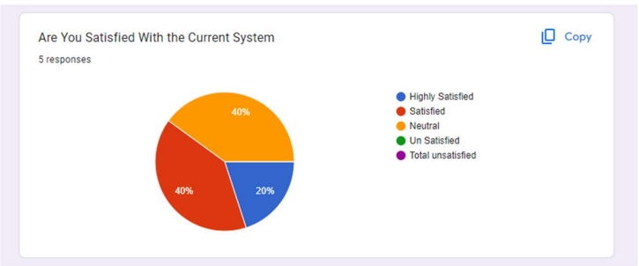

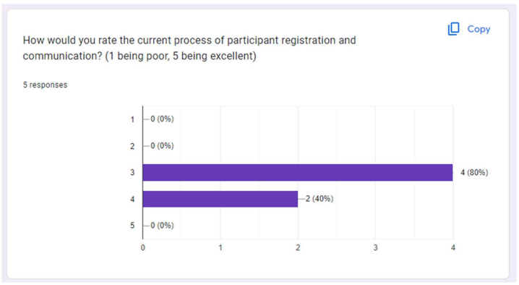

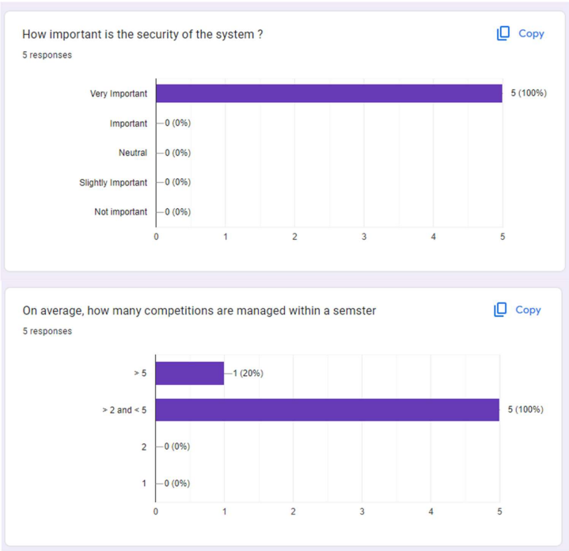

# System Users

# 

1. **Organizers:** The organizers will use the database to modify competitions, open registration forms, and manage all deadlines. They will also be responsible for allocating invigilators and judges.

2. **Admins:** The administrators will implement and design the DB to ensure security, monitoring, and implement backup and data recovery.

3. **Contestants:** the contestants will use the DB to register for the competitions and view details regarding their competition such as date, venue, and results.

4. **Judges:** the judges will evaluate and score the submissions or performances. They will access the system to review entries, assign scores or marks, and provide feedback. They have access to all contestants of the following competition.

5. **Invigilators:** the invigilators will use the DB to check for their duties assigned to them, they will check for their duty venue, time.

# Functionalities

## Registration Process

- Contestants register for competitions by providing personal details and, if applicable, forming teams.

- The registration form captures essential information and integrates it into the CMS database.

- Organizers manage the registration process, including opening/closing registration forms and monitoring registration status.

Competition Management Organizers create, update, and delete competitions, including rules, problem statements, and schedules.

Participant Management Contestants and teams are entered, updated, or removed from the system, ensuring accurate record-keeping.

Judging and Evaluation Judges access contestants' submissions, assign scores, and provide feedback, ensuring consistency in judging criteria.

Search Functionality Users search for upcoming and previous contests, judges, invigilators, locations, and past results, enhancing accessibility.

Reporting The system generates reports on competition results, timings, judging fairness, marketing outcomes, reach, and encountered issues, providing valuable insights.

# Block Diagram

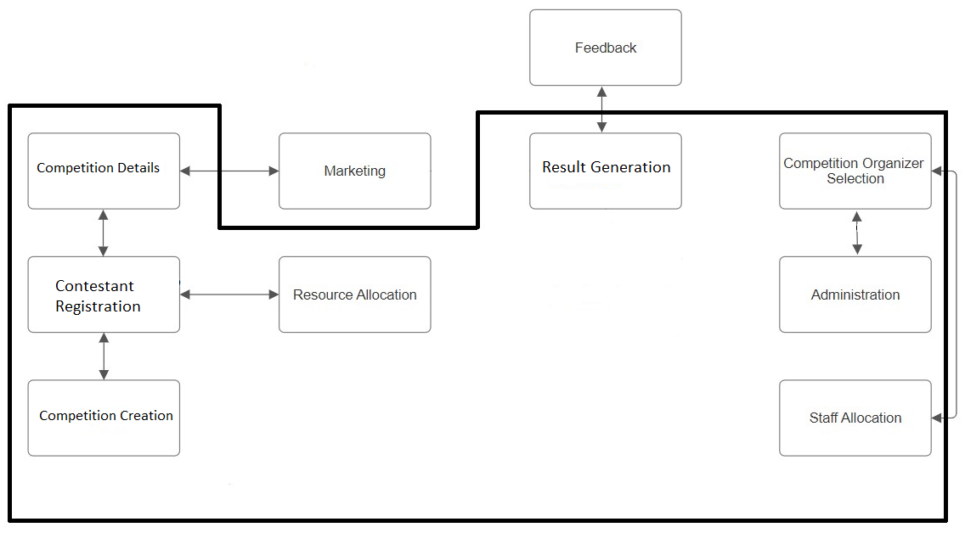

# System Specifications

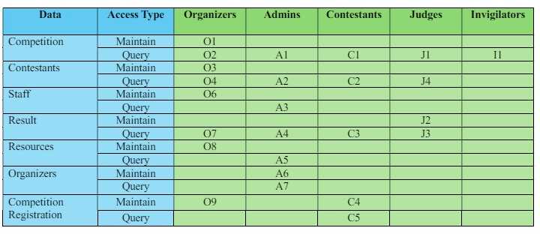

# User Views

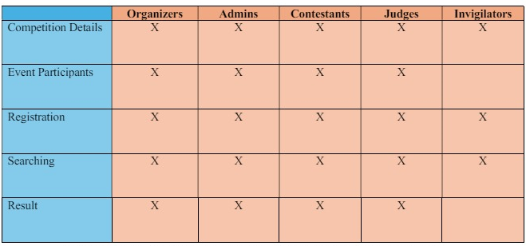

# User Views & Wire-frames

**Frame Number 1:**

**Login Page:**

|  |  |  |  |  |  |
| --- | --- | --- | --- | --- | --- |
| **WireFrame ID** | V1 | | | | |
| **User** | Everyone | | | | |
| **UserView Req** | N/A | | | | |
| **Component** | **Description** | **Input** | **Output** | **Action** | **Require DB Access** |
| Contestant | Redirects user to Contestant Login Page |  |  | User Redirected to View V3 |  |
| Organizer | Redirects user to Organizer Login Page |  |  | User Redirected to View V4 |  |
| Judge | Redirects user to Judge Login Page |  |  | User Redirected to View V5 |  |
| Admin | Redirects user to Admin Login Page |  |  | User Redirected to View V6 |  |
| Invigilator | Redirects user to Invigilator Login Page |  |  | User Redirected to View V7 |  |

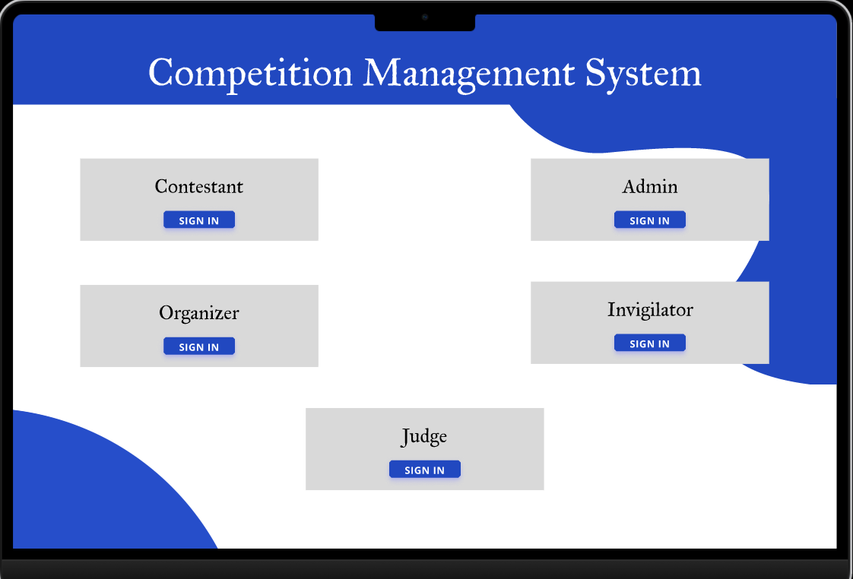

**Frame Number 2:**

**SignUp Page:**

|  |  |  |  |  |  |
| --- | --- | --- | --- | --- | --- |
| **WireFrame ID** | V2 | | | | |
| **User** | Everyone | | | | |
| **UserView Req** | O3, O6 | | | | |
| **Component** | **Description** | **Input** | **Output** | **Action** | **Require DB Access** |
| Username | Ask user for its username |  |  |  |  |
| First Name | Ask user for its first name |  |  |  |  |
| Last Name | Ask user for its last name |  |  |  |  |
| Phone | Ask user for its phone number |  |  |  |  |
| Email | Ask user for its email |  |  |  |  |
| CNIC | Ask user for its CNIC |  |  |  |  |
| Passport | Ask user for its passport |  |  |  |  |
| Password | Ask user for their password |  |  |  |  |
| Role | Let’s the user select their role |  |  |  |  |
| Complete Registration | Fetches all the above details and Stores |  |  | Redirects to user to homepage |  |

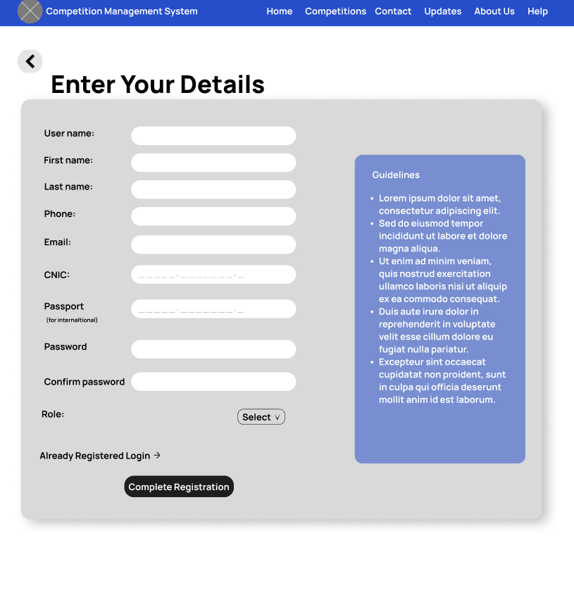

**Frame Number 3:**

**Contestant Login Page:**

|  |  |  |  |  |  |
| --- | --- | --- | --- | --- | --- |
| **WireFrame ID** | V3 | | | | |
| **User** | Contestant | | | | |
| **UserView Req** | N/A | | | | |
| **Component** | **Description** | **Input** | **Output** | **Action** | **Require DB Access** |
| Username | User enters the username already created |  |  |  |  |
| Password | User enters the password already created in registration view |  |  |  |  |
| Login | Button: User presses button to sign |  |  | Username and password verified, and user logged in/ Error shown |  |
| Forgot Password | Link |  |  |  |  |

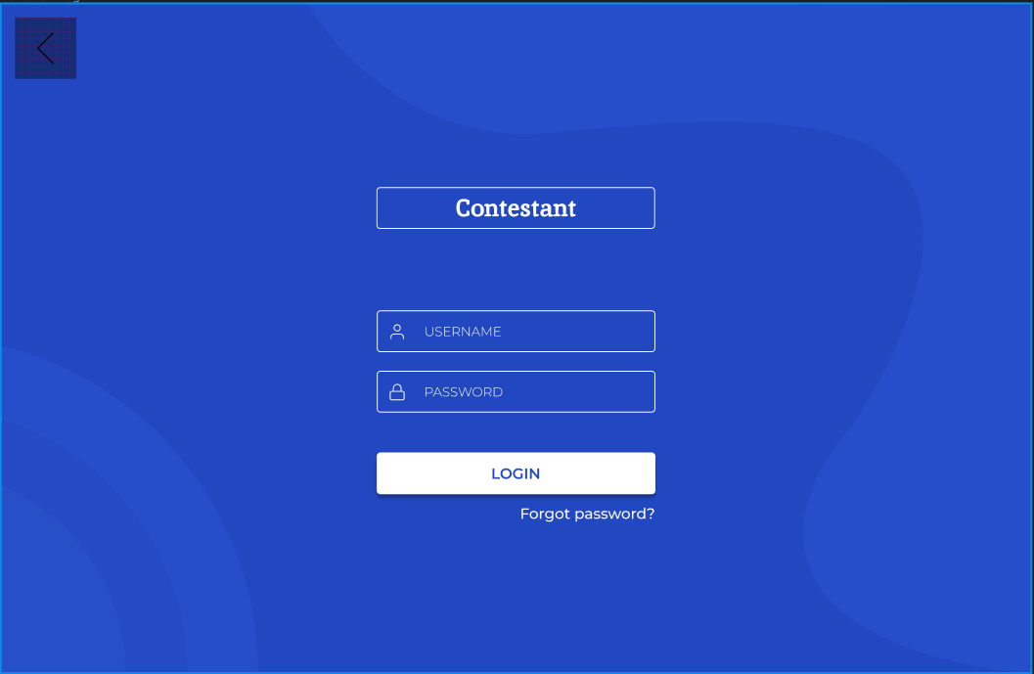

Similarly frames V4,V5,V6 and V7 does the same functionality but redirects to their respective dashboards.

**Frame Number 8:**

**Contestant Dashboard:**

|  |  |  |  |  |  |
| --- | --- | --- | --- | --- | --- |
| **WireFrame ID** | V8 | | | | |
| **User** | Contestant | | | | |
| **UserView Req** | C1, C2, C3, C4, C5 | | | | |
| **Component** | **Description** | **Input** | **Output** | **Action** | **Require DB Access** |
| UpComing Competitions | All the upcoming competitions are listed here |  |  | Table displayed containing all the upcoming competitions |  |
| Register Now **Button** | Allows the user to register for a contest |  |  | Button: Pressed to register |  |
| Previous Competitions | All the Previous competitions are listed here |  |  | Table displayed containing all the previous competitions |  |
| View previous results **Button** | User can View all the previous results |  |  | User Redirected to the bottom pf the page |  |
| Previous Results | Displays all the previous competitions results in which the user competed in |  |  |  |  |

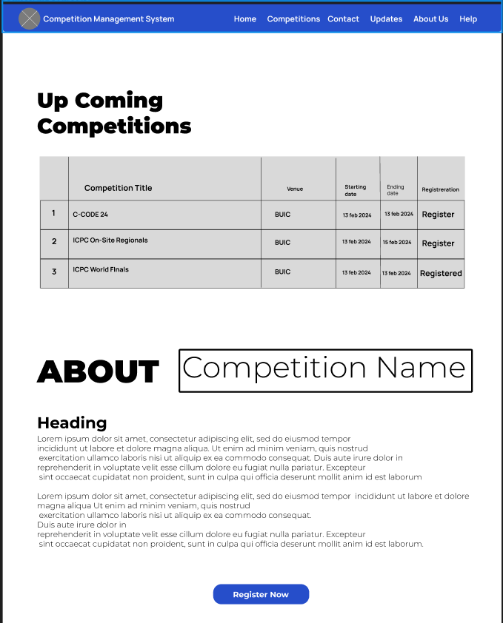

**End of Contestant Wire Frames**

**Frame Number 9:**

**Invigilator Dashboard: (After Logging In From Frame V7)**

|  |  |  |  |  |  |
| --- | --- | --- | --- | --- | --- |
| **WireFrame ID** | V9 | | | | |
| **User** | Invigilator | | | | |
| **UserView Req** | I1 | | | | |
| **Component** | **Description** | **Input** | **Output** | **Action** | **Require DB Access** |
| Upcoming Competitions | All the upcoming competitions are listed here |  |  | Table displayed containing all the upcoming competitions |  |
| Details **Button** | Button to redirect to the details section |  |  | User Redirected to the bottom of the page |  |
| Previous Competitions | All the Previous competitions are listed here |  |  | Table displayed containing all the previous competitions |  |

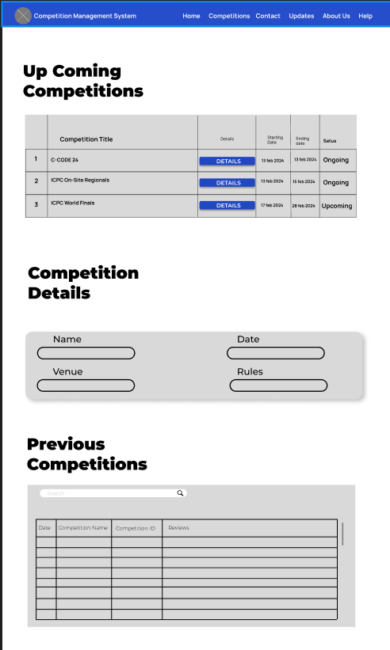

**End of Invigilator Frames**

**Frame Number 10:**

**Judge Dashboard: (After Logging In From Frame V5)**

|  |  |  |  |  |  |
| --- | --- | --- | --- | --- | --- |
| **WireFrame ID** | V10 | | | | |
| **User** | Judge | | | | |
| **UserView Req** | J1, J2 | | | | |
| **Component** | **Description** | **Input** | **Output** | **Action** | **Require DB Access** |
| UpComing Competition | All the upcoming competitions are listed here |  |  | Table displayed containing all the upcoming competitions |  |
| Previous Competitions | All the Previous competitions are listed here |  |  | Table displayed containing all the previous competitions |  |
| Details | Link | |  | | --- | |  | |  | User Redirected to the bottom of the page |  |
| Result **Button** | Button to redirect to the results section |  |  |  |  |
| Previous Results | All the Previous competitions results are listed here |  |  |  |  |

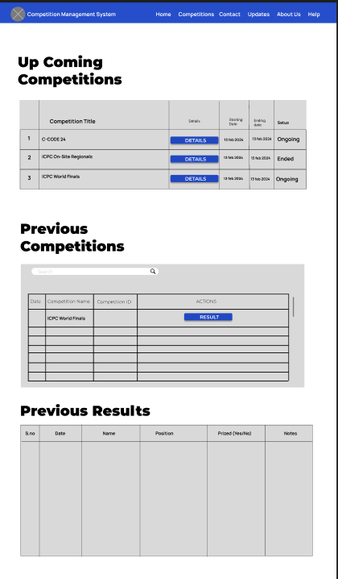

**Frame Number 11:**

**Judge Competition Details:**

|  |  |  |  |  |  |
| --- | --- | --- | --- | --- | --- |
| **WireFrame ID** | V11 | | | | |
| **User** | Judge | | | | |
| **UserView Req** | J3, J4 | | | | |
| **Component** | **Description** | **Input** | **Output** | **Action** | **Require DB Access** |
| Name | Displays the name of competition |  |  |  |  |
| Date and Time | Displays the date and time of competition |  |  |  |  |
| Venue | Displays the venue of competition |  |  |  |  |
| Contestants | Displays the list of contestants registered in the contest |  |  | Table displayed containing all the contestants |  |
| Generate Result | Link |  |  | User Redirected to the bottom of the page |  |
| Results Entry | To enter the result |  |  | Allows the judge to enter the result of every contestant one by one |  |
| Save | Button |  |  | Saves the inserted result into the DB |  |

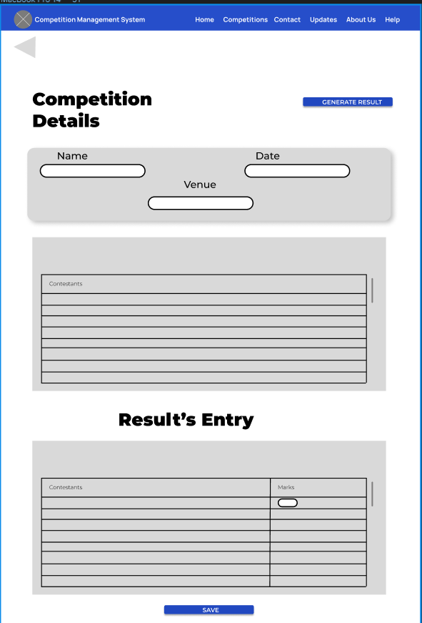

**Frame Number 12:**

**Admin Dashboard: (After Logging In From Frame V6)**

|  |  |  |  |  |  |
| --- | --- | --- | --- | --- | --- |
| **WireFrame ID** | V12 | | | | |
| **User** | Admin | | | | |
| **UserView Req** | A1, A4 | | | | |
| **Component** | **Description** | **Input** | **Output** | **Action** | **Require DB Access** |
| Organizers | All the competition organizers are listed here |  |  |  |  |
| Upcoming Competitions | All the upcoming competitions are listed here |  |  |  |  |
| Previous Competitions | All the previous competitions are listed here |  |  |  |  |
| Modify | Link |  |  | User redirected to view V13 |  |
| Details | Link |  |  | User redirected to view V14 |  |
| Result | Link |  |  | User redirected to the bottom of the page |  |
| Previous Results | Previous result of the selected competition is displayed here |  |  |  |  |

**Frame Number 13:**

**Admin Organizer Modify:**

|  |  |  |  |  |  |
| --- | --- | --- | --- | --- | --- |
| **WireFrame ID** | V13 | | | | |
| **User** | Admin | | | | |
| **UserView Req** | A6, A7 | | | | |
| **Component** | **Description** | **Input** | **Output** | **Action** | **Require DB Access** |
| Organizers | All the competition organizers are listed here |  |  |  |  |
| Add Organizer **Button** | Link |  |  | User redirected to the bottom of the page |  |
| Remove Organizer | Removes the selected organizer from the list |  |  |  |  |
| Add Organizer | Dialog to add the organizer to the DB |  |  |  |  |
| Organizer Name | Name of the organizer to be added |  |  |  |  |
| Organizer ID | ID of the organizer to be added (can be automated) |  |  |  |  |
| Save Button | Save the above entered Information |  |  | The added information is saved in the DB |  |

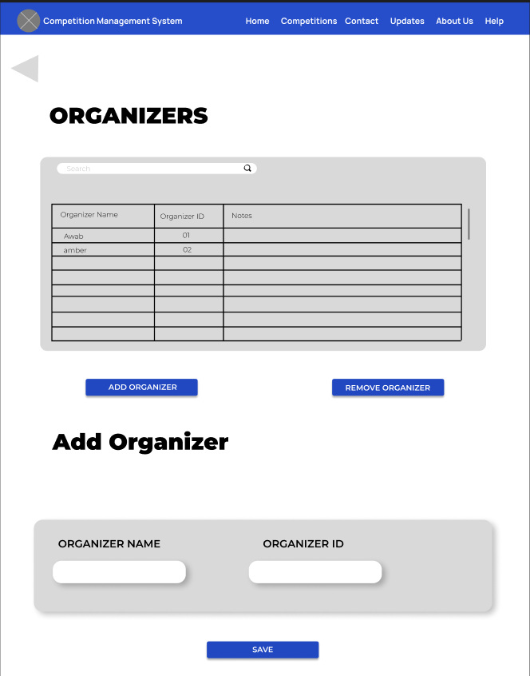

**Frame Number 14:**

**Admin Up Coming Competition Details:**

|  |  |  |  |  |  |
| --- | --- | --- | --- | --- | --- |
| **WireFrame ID** | V14 | | | | |
| **User** | Admin | | | | |
| **UserView Req** | A2, A3, A5 | | | | |
| **Component** | **Description** | **Input** | **Output** | **Action** | **Require DB Access** |
| Competitions Details | Displays all the information regarding the name of competition, Date, Venue, Rules, Names of Judges, Invigilators, Organizers, Contestants, Teams, and the list of resources used |  |  |  |  |

**Frame Number 15:**

**Organizer Dashboard: (After Logging From User View V4)**

|  |  |  |  |  |  |
| --- | --- | --- | --- | --- | --- |
| **WireFrame ID** | V15 | | | | |
| **User** | Organizer | | | | |
| **UserView Req** | O2, O7 | | | | |
| **Component** | **Description** | **Input** | **Output** | **Action** | **Require DB Access** |
| Upcoming Competitions | All the upcoming competitions are listed here |  |  |  |  |
| Previous Competitions | All the previous competitions are listed here |  |  |  |  |
| Result | Link |  |  | User redirected to the bottom of the page |  |
| Previous Results | Previous result of the selected competition is displayed |  |  |  |  |
| Create New | Link |  |  | User redirected to view V16 |  |
| Details | Link |  |  | User redirected to view V17 |  |

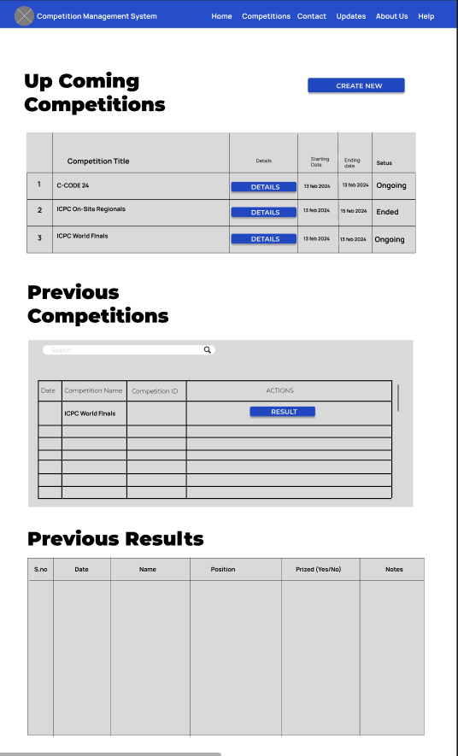

**Frame Number 16:**

**Organizer Create New Competition Dashboard:**

|  |  |  |  |  |  |
| --- | --- | --- | --- | --- | --- |
| **WireFrame ID** | V16 | | | | |
| **User** | Organizer | | | | |
| **UserView Req** | O1, O6, O8, O9 | | | | |
| **Component** | **Description** | **Input** | **Output** | **Action** | **Require DB Access** |
| Competition Creation | Gathers the details from the organizer such as Competition Name, Date, Venue, Rules |  |  | Data Entry |  |
| Judges | Table displaying all the judges assigned for that competition |  |  |  |  |
| Add Judge **Button** | Used to assign a new judge |  |  | User redirected to the Add Judge dialogue below |  |
| Remove Judge **Button** | Used to remove the selected Judge |  |  | Selected Judge is removed from the competition |  |
| Invigilators | Table displaying all the invigilators assigned for that competition |  |  |  |  |
| Add Invigilator **Button** | Used to assign a new invigilator |  |  | User redirected to the Add Invigilator dialogue below |  |
| Remove Invigilator **Button** | Used to remove the selected Invigilator |  |  | Selected Invigilator is removed from the competition |  |
| Add a Judge **Dialogue** | Allows the organizer to add a new judge to the competition |  |  | Information collected and added to DB |  |
| Add an Invigilator **Dialogue** | Allows the organizer to add a new invigilator to the competition |  |  | Information collected and added to DB |  |
| Resource Allocation | Table displaying all the allocated resource for the competition |  |  |  |  |
| Add Item **Button 1** | Link |  |  | Redirects to the bottom of the page |  |
| Add Item **Button 2** | Used to save entered data into DB |  |  |  |  |

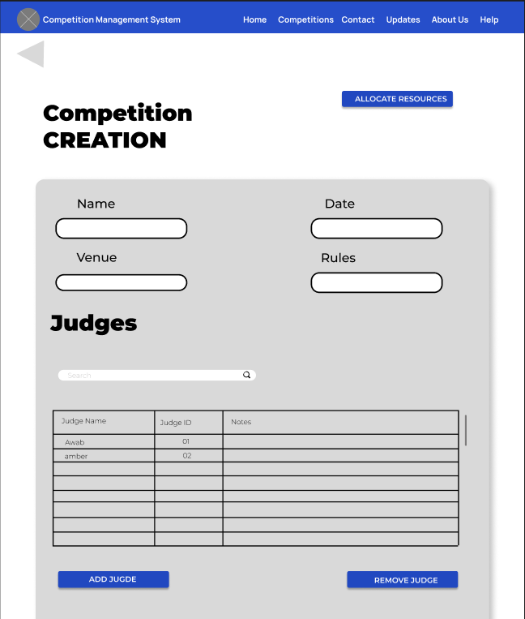

**Frame Number 17:**

**Organizer Upcoming Competition Details:**

|  |  |  |  |  |  |
| --- | --- | --- | --- | --- | --- |
| **WireFrame ID** | V17 | | | | |
| **User** | Organizer | | | | |
| **UserView Req** | O1, O4, O6, O8, O9 | | | | |
| **Component** | **Description** | **Input** | **Output** | **Action** | **Require DB Access** |
| Competition Details | Shows informtaion of the contest like Name, Date/time, Venue and Rules |  |  |  |  |
| Delete Contest **Button** | Deletes the contest and all its details from the DB |  |  |  |  |
| Judges | Table displaying all the judges assigned for that competition |  |  |  |  |
| Add Judge **Button** | Used to assign a new judge |  |  | User redirected to the Add Judge dialogue below |  |
| Remove Judge **Button** | Used to remove the selected Judge |  |  | Selected Judge is removed from the competition |  |
| Invigilators | Table displaying all the invigilators assigned for that competition |  |  |  |  |
| Add Invigilator **Button** | Used to assign a new invigilator |  |  | User redirected to the Add Invigilator dialogue below |  |
| Remove Invigilator **Button** | Used to remove the selected Invigilator |  |  | Selected Invigilator is removed from the competition |  |
| Add a Judge **Dialogue** | Allows the organizer to add a new judge to the competition |  |  | Information collected and added to DB |  |
| Add an Invigilator **Dialogue** | Allows the organizer to add a new invigilator to the competition |  |  | Information collected and added to DB |  |
| Registered Contestants | Displays the list of all the contestants already registered for that contest |  |  |  |  |
| Allocated Resources | Table displaying all the allocated resource for the competition |  |  |  |  |
| Add Item **Button 1** | Link |  |  | Redirects to the bottom of the page |  |
| Allocate New Resource | Allows the Organizer to add new resource for the competition |  |  |  |  |
| Add Item **Button 2** | Used to save entered data into DB |  |  |  |  |

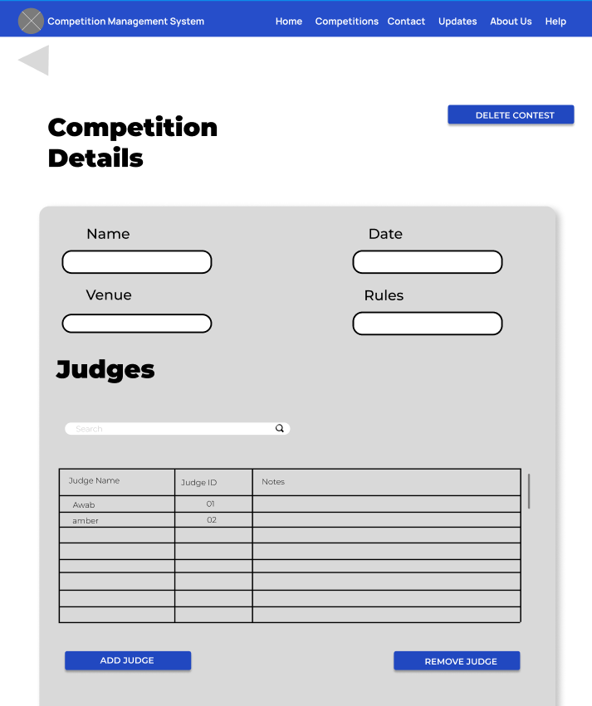

# Approach

## Centralized Approach

**Reasons**

* **Overlapping/Common Requirements:** When there is a substantial overlap in the data requirements across various user views, it makes sense to adopt a centralized approach. This means that many users share similar needs or interact with similar data entities and relationships.
* **Simplified System Complexity:** For less complex database systems or applications with relatively straightforward data structures, a centralized approach can effectively capture and represent the necessary information without excessive complexity. This approach streamlines the design process by focusing on commonalities rather than intricacies of individual views.
* **Streamlined Requirement Gathering:** Collating all user views into a single list of requirements simplifies the initial phase of requirement gathering. Instead of managing multiple lists, a single comprehensive list is created, reducing confusion and redundancy.

# List Of Entities

1. Person

2. Admin

3. Organizer

4. Judge

5. Invigilator

6. Contestant

7. Competition

8. Result

9. Resource

10. Attendees

# Attributes

1. **Person:**

* ID
* F_name
* L_name
* Email
* Phone#
* Age
* Gender
* Username
* Password
* CNIC

1. **Admin:**

* All super class attributes only.

1. **Judge:**

* All super class attributes, Status

1. **Invigilator:**

* All super class attributes, Status

1. **Organizer:**

* All super class attributes, Status

1. **Contestant:**

* All super class attributes, Status

1. **Competition:**

* Event_ID
* Location
* Date
* Status
* Rules
* Description
* Time

1. **Result:**

* Winner_ID
* RunnerUp_ID

1. **Resource:**

* Item_ID
* Item_name
* Quantity

1. **Attendees:**

* Event_ID
* Roll#
* Email
* F_name
* L_name

# List Of Relations

1. Admin ===Allots=== Organizer
2. Admin ===View=== Competition
3. Organizer ===Allots=== Judge
4. Organizer ===Allots=== Invigilator
5. Organizer ===Creates=== Competition
6. Organizer ===View=== Competition
7. Organizer ===View=== Result
8. Organizer ===Select=== Resources
9. Contestant===Participates In===Competition
10. Judge ===Judges=== Competition
11. Judge ===Generates=== Result
12. Invigilator ===Invigilates=== Competition
13. Event ===Has===Result
14. Event ===Has===Resources
15. Event ===Has===Attendees

# Constraints

## Domains Of Attributes With Domain Constraints

1. **dom(F_name)** = Accept character values of maximum length 25. Applicable for Admin, Organizer, Judge, Invigilator, Contestant.

* NOTNULL

1. **dom(L_name)** = Accept character values of maximum length 25. Applicable for Admin, Organizer, Judge, Invigilator, Contestant.

* NOTNULL

1. **dom(Email)** = Accepts variable character values up to a maximum length of 255 characters. Applicable for Admin, Organizer, Judge, Invigilator, Contestant.

* NOTNULL

1. **dom(Phone#)** = Accept numeric values of maximum length 25. Applicable for Admin, Organizer, Judge, Invigilator, Contestant.

* NOTNULL

1. **dom(Age)** = Accept numeric values of maximum length 2. Applicable for Admin, Organizer, Judge, Invigilator, Contestant.

* NOTNULL

1. **dom(Gender)** = Accept single character value. Applicable for Admin, Organizer, Judge, Invigilator, Contestant.

* NOTNULL

1. **dom(Username)** = Accept variable character values of maximum length 25. Applicable for Admin, Organizer, Judge, Invigilator, Contestant.

* NOTNULL

1. **dom(Password)** = Accept variable character values of maximum length 25. Applicable for Admin, Organizer, Judge, Invigilator, Contestant.

* NOTNULL

1. **dom(CNIC)** = Accept numeric values of maximum length 13 with 2 dashes E.g( xxxxx-xxxxxxx-x). Applicable for Admin, Organizer, Judge, Invigilator, Contestant.

* NOTNULL

1. **dom(ID)** = Accept variable character values of maximum length 10. Applicable for Admin, Organizer, Judge, Invigilator, Contestant.

* NOTNULL

1. **dom(Status)** = Accept single number value either 1 Or 0. Applicable for Competition, Organizer, Judge, Invigilator, Contestant.

* NOTNULL

1. **dom(Event_ID)** = Accept variable character values of maximum length 10. Applicable for Competition.

* NOTNULL

1. **dom(Location)** = Accept variable character values of maximum length 255. Applicable for Competition.

* NOTNULL

1. **dom(Date)** = Accept numeric values in format DD-MM-YYYY. Applicable for Competition.

* NOTNULL

1. **dom(Rules)** = Accept text (no specified length). Applicable for Competition.

* NULL

1. **dom(Description)** = Accept text (no specified length). Applicable for Competition.

* NULL

1. **dom(Time)** = Accept numeric values in format HH:MM:SS. Applicable for Competition.

* NOTNULL

1. **dom(Winner_ID)** = Accept variable character values of maximum length 10. Applicable for Result.

* NOTNULL

1. **dom(RunnerUp_ID)** = Accept variable character values of maximum length 10. Applicable for Result.

* NULL

1. **dom(Item_ID)** = Accept variable character values of maximum length 10. Applicable for Resource.

* NOTNULL

1. **dom(Item_name)** = Accept character values of maximum length 25. Applicable for Competition. Applicable for Resource.

* NOTNULL

1. **dom(Quantity)** = Accept numeric values of maximum length 3. Applicable for Resource.

* NOTNULL

1. **dom(Event_ID)** = Accept variable character values of maximum length 10. Applicable for Attendees.

* NOTNULL

1. **dom(Roll#)** = Accept variable character values of maximum length 10. Applicable for Attendees.

* NOTNULL

1. **dom(Email)** = Accepts variable character values up to a maximum length of 255 characters. Applicable for Attendees.

* NOTNULL

1. **dom(F_name)** = Accept character values of maximum length 25. Applicable for Attendees.

* NOTNULL

1. **dom(L_name )** = Accept character values of maximum length 25. Applicable for Attendees.

* NOTNULL

## Referential Integrity Constraint

* Person ( ID ) is a foreign key in: Admin ( Admin_ID ), Organizer ( Org_ID ), Judge ( Judge_ID ), Invigilator ( Invig_ID ), Contestant ( Roll# )
* Competition ( Event_ID ) is a foreign key in: Result ( Event_Identifier ), Resources ( R_Event_ID ), Attendees ( Event_ID )
* Contestant ( Roll# ) is a foreign key in: Attendees ( Roll# )

## Entity Entegrity Constraints

* **Admin_ID** in **Admin** is the primary key, ensuring each **Admin** has unique identifier
* **Org_ID** in **Organizer** is the primary key, ensuring each **Organizer** has unique identifier
* **Judge_ID** in **Judge** is the primary key, ensuring each **Judge** has unique identifier
* **Invig_ID** in **Invigilator** is the primary key, ensuring each **Invigilator** has unique identifier
* **Roll#** in **Contestant** is the primary key, ensuring each **Contestant** has unique identifier
* **Event_ID** in **Competition** is the primary key, ensuring each Competition has unique identifier
* **Item_ID** in **Resource** is the primary key, ensuring each Resource has unique identifier

## Key Constraints

Key constraints in a database system can be violated if there are non-distinct or repeated values within tuples. Specifically, in the context of candidate keys, removing any attribute from a candidate key would cause that attribute to lose its uniqueness property, thereby compromising the integrity of the key constraint.

* **Admin_ID** in **Admin** is a unique identifier.
* **Org_ID** in **Organizer** is a unique identifier.
* **Judge_ID** in **Judge** is a unique identifier.
* **Invig_ID** in **Invigilator** is a unique identifier.
* **Roll#** in **Contestant** is a unique identifier.
* **Event_ID** in **Competition** is a unique identifier.
* **Item_ID** in **Resource** is a unique identifier.

# Relation Definition

1. **Person** ( ID, F_name, L_name, Email, Phone#, Age, Gender, Username, Password, CNIC)
2. **Admin** ( Admin_ID)
3. **Organizer** ( Org_ID, Status)
4. **Judge** ( Judge_ID, Status)
5. **Invigilator** ( Invig_ID, Status)
6. **Contestant** ( Roll#, Status)
7. **Competition** ( Event_ID, Status, Location, Date, Time, Rules, Description)
8. **Result** ( Winner_ID, RunnerUp_ID, Event_Identifier)
9. **Resource** ( Item_ID, R_Event_ID, Quantity, Item_name)
10. **Attendees** ( Event_ID, Roll#, Email, F_name, L_name)

# ERD

# 

# Block & Arrow

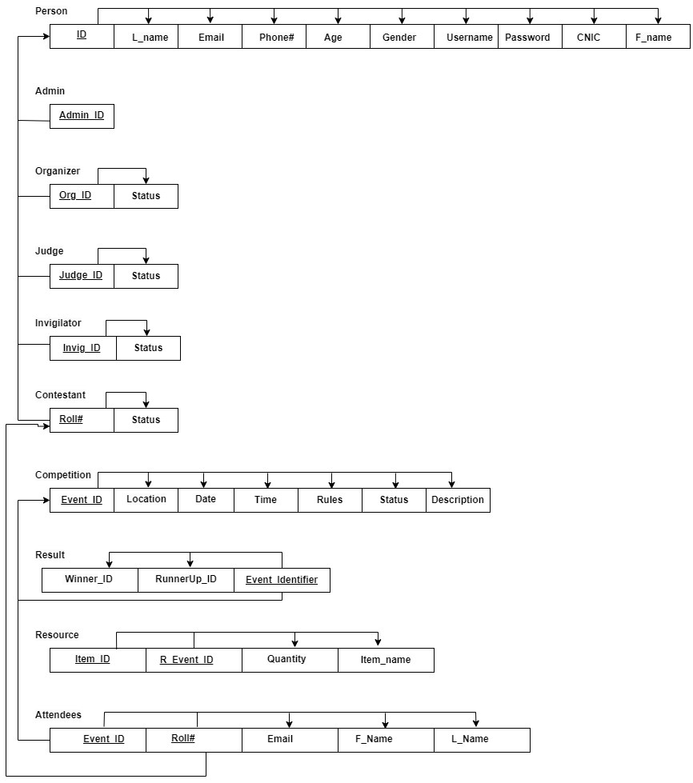

# Tables and Constraints

CREATE TABLE Person (

person_id INT AUTO_INCREMENT PRIMARY KEY,

f_name VARCHAR(50),

l_name VARCHAR(50),

email VARCHAR(100) UNIQUE,

phone VARCHAR(15),

age INT,

gender CHAR(1),

username VARCHAR(50) UNIQUE,

password VARCHAR(100),

cnic VARCHAR(15)

);

CREATE TABLE Admin (

admin_id INT AUTO_INCREMENT PRIMARY KEY,

person_id INT,

FOREIGN KEY (person_id) REFERENCES Person(person_id)

);

CREATE TABLE Organizer (

organizer_id INT AUTO_INCREMENT PRIMARY KEY,

person_id INT,

status VARCHAR(50),

FOREIGN KEY (person_id) REFERENCES Person(person_id)

);

CREATE TABLE Judge (

judge_id INT AUTO_INCREMENT PRIMARY KEY,

person_id INT,

status VARCHAR(50),

FOREIGN KEY (person_id) REFERENCES Person(person_id)

);

CREATE TABLE Invigilator (

invig_id INT AUTO_INCREMENT PRIMARY KEY,

person_id INT,

status VARCHAR(50),

FOREIGN KEY (person_id) REFERENCES Person(person_id)

);

CREATE TABLE Competition (

event_id INT AUTO_INCREMENT PRIMARY KEY,

name VARCHAR(100),

venue VARCHAR(100),

date DATE,

starting_time TIME,

ending_time TIME,

rules TEXT,

description TEXT,

status VARCHAR(50)

);

CREATE TABLE Result (

result_id INT AUTO_INCREMENT PRIMARY KEY,

event_id INT,

winner_id INT,

runner_up_id INT,

FOREIGN KEY (event_id) REFERENCES Competition(event_id)

);

CREATE TABLE Resource (

item_id INT AUTO_INCREMENT PRIMARY KEY,

event_id INT,

item_name VARCHAR(100),

quantity INT,

FOREIGN KEY (event_id) REFERENCES Competition(event_id)

);

CREATE TABLE Attendees (

attendee_id INT AUTO_INCREMENT PRIMARY KEY,

event_id INT,

person_id INT,

FOREIGN KEY (event_id) REFERENCES Competition(event_id),

FOREIGN KEY (person_id) REFERENCES Person(person_id)

);

CREATE TABLE CompetitionJudge (

comp_judge_id INT AUTO_INCREMENT PRIMARY KEY,

event_id INT,

judge_id INT,

FOREIGN KEY (event_id) REFERENCES Competition(event_id),

FOREIGN KEY (judge_id) REFERENCES Judge(judge_id)

);

CREATE TABLE CompetitionInvigilator (

comp_invig_id INT AUTO_INCREMENT PRIMARY KEY,

event_id INT,

invig_id INT,

FOREIGN KEY (event_id) REFERENCES Competition(event_id),

FOREIGN KEY (invig_id) REFERENCES Invigilator(invig_id)

);

CREATE TABLE CompetitionResource (

comp_resource_id INT AUTO_INCREMENT PRIMARY KEY,

event_id INT,

item_id INT,

FOREIGN KEY (event_id) REFERENCES Competition(event_id),

FOREIGN KEY (item_id) REFERENCES Recource(item_id)

);

# Final Result:

## Screen 1: Login Screen

## Screen 2: Signup Screen

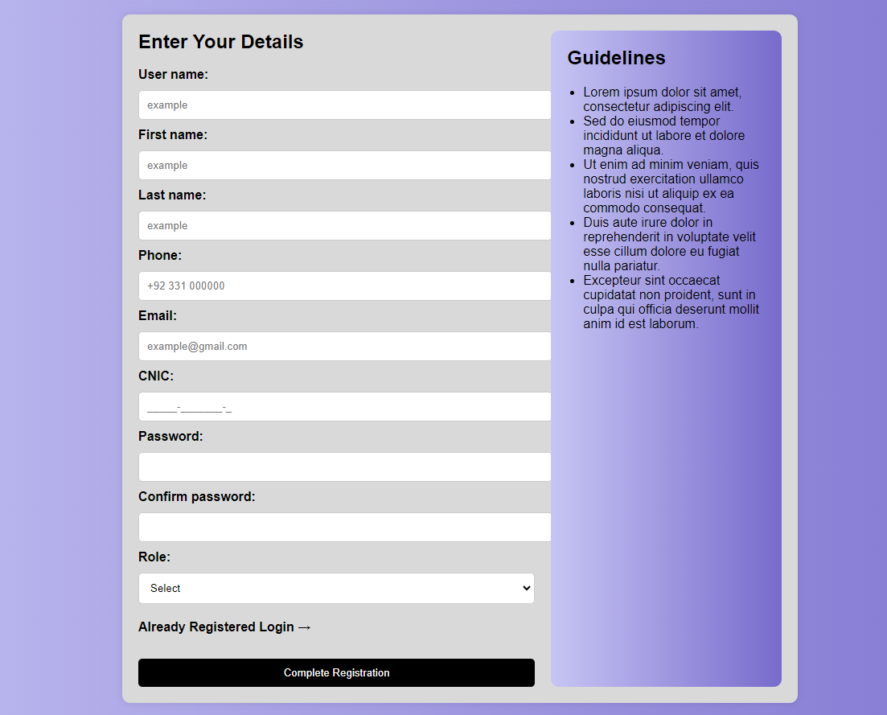

## Screen 3: Contestant Dashboard

## Screen 4: Admin Dashboard

## Screen 5: Admin Details

## Screen 6: Admin Organizer Modify

## Screen 7: Invigilator Dashboard

## Screen 8: Judge Dashboard

## Screen 9: Judge Details and Result

## Screen 10: Organizer Dashboard

## Screen 11: Organizer Create New Competition

## Screen 12: Organizer Modify Competition

**Regards**